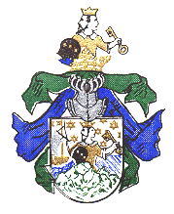**Dollhopf**

**600 Years in the Baking**

**Adam and Eve Dollhopf: Our DNA Origins**

Our immigrant ancestor John Dollhopf came from Germany.

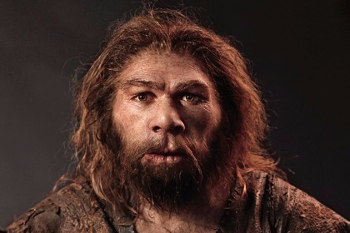

*Meet our 11,000x-great-grandfather, “Adam” Dollhopf. He lived 275,000 years ago in East Africa. I don’t think he spoke German.*

But where did *his* ancestors come from?

A good question, and DNA testing is beginning to provide answers.

Before Germany, our grandfathers lived in Hungary. Before then, the Caspian Steppe in the area of Georgia (the country, not the state). Before then the Arabian Peninsula. Before then, East Africa.

Here is the latest approximation of the migratory route of our grandfathers and the approximate time of their migration (grandmothers will be different as you will see):[1]

~ 11,000th great-grandfather – 275,000 years ago in East Africa.

~ 3,040th great-grandfather – 76,000 years ago on the Arabian Peninsula.

~ 2,160th great-grandfather – 54,000 years ago on the Black Sea-Caspian Steppe.

~ 440th great-grandfather – 11,000 years ago in Hungary.

~ 260th great-grandfather – 6,500 years ago in Central Europe.

~ 152nd great-grandfather – 3,800 years ago (1800 to 1500 BCE) in Oberfranken

1st great-grandfather John Dollhopf – exactly 138 years ago (1871) in America.

We know the approximate date and location of our grandfathers’ existences because of mutations in their genes.[2]

For 200,000 years, our first ancestor, first in the list above, (let's call him “Adam”) lived in East Africa. Then a mutation occurred in the DNA of his 7,960th grandson. Let’s call him Cain. Cain was a mutant. He had a different set of genes. (Mutations are a common occurrence in all living things.) That mutation, which occurred ~200,000 years ago, is a genetic “marker” that can be seen in my – and your – genes today. Cain’s genes were different, and for 21,000 years Cain and his progeny lived on the Arabian Peninsula.[3] We know this because there are people living today on the Arabian Peninsula who have the same genetic marker.

Then, about 54,000 years ago, another mutation occurred in a grandson, let's call him “Enoch.” Enoch now had his father’s *and* his great-grandfather’s genetic markers (separated by tens of thousands of years). Think of them as tattoos. An individual that experiences a mutation bears a new tattoo – as well as all of the tattoos that came before.

Our genes are molecular clocks that bear the time stamps of all the genetic mutations that have occurred in our direct line of paternal ancestors for the past ~275,000 years. Current research suggests that mutations occur, on average, every 8,000 years.

**Genetics Explained**

Well, maybe not. I was a religious studies major. What the heck do I know? But did you like the Adam, Cain, and Enoch analogy?

I am not an expert on genetics. I can barely spell deoxyribonucleic acid (DNA), centiMorgans, single nucleotide polymorphisms (SNPs) and the like.

But I’ll try my best to explain this to my fellow humanities majors.

For an excellent, entertaining, and easy to understand explanation of how *real* scientists trace our DNA evolutionary origins, check out the documentary *The Journey of Man – A Genetic Odyssey* by Stanford scientist Spencer Wells. You can view it on YouTube at <https://www.youtube.com/watch?v=W_xTG6VXlIQ&t=4s> It's absolutely fascinating.

Everyone has a blood type, and we are “grouped” with others according to our blood type. As you probably know there are eight major, common, blood types: A+, A-, B+, B-, O+, O-, AB+, AB-.

In addition to a *blood* type, everyone also has a *gen*otype, and we are “grouped” with others who share our genetic characteristics. These groups are called *haplo*groups. Everyone in a specific haplogroup shares a *single* common ancestor. Think of a haplogroup as a clan or a tribe, all of whose members descended from one person.

You belong to two haplogroups – your father’s group, which is called your Y-chromosome haplogroup (Y-

DNA), and your mother’s group, which is called your mitochondrial DNA haplogroup (mtDNA). You belong to two tribes, a Y-DNA tribe, and a mtDNA tribe.

**Your father’s group.** There are eight major *paternal*, or Y-DNA, haplogroups. They are labeled: R1, J, E, A, C, O, L, and Q.[4] If you are a direct male descendant of John Dollhopf, you belong to the “A” group. If you are a woman, you are in the A group *only if your father’s name is Dollhopf* – a direct male descendant. Otherwise, of course, you belong to your biological father’s haplogroup. Y-DNA is passed only from father to son, *not* father to daughter.

**Your mother’s group**. There are fourteen major *maternal*, or mtDNA, haplogroups. They are labeled L1, L2, L3, B, C, D, M, Y, N, P, A, B, C, and D. You inherit your mtDNA only from your mother, so if you are reading this I don’t know your mtDNA group, unless you are my sibling (Kevin and Kristin, your mtDNA group is K1c1b). You’ll have to discover this from your mother, or be tested yourself.

I don’t know the mtDNA of John’s wife Elizabeth Bender, but you will not have it unless you are Elizabeth’s daughter’s daughter’s daughter. Any female descendant of Edward Dollhopf will not have Elizabeth’s mtDNA. You would have to be a descendant of Edward’s sisters – Jennie and Elanora. The mtDNA is passed only through the female line, daughter to daughter to daughter.

Unlike Y-DNA, mtDNA is passed from mother to *both* son and daughter. Because females do not have a Y chromosome, they cannot be tested for Y-DNA origins. Women only know this through their father, brother, paternal uncle, or paternal grandfather – or as I said above, men with the name Dollhopf.

Everyone has an ancestral Adam and Eve, although genetics has proven that there was not a *single* Adam and Eve. So much for my religious studies training.

**What’s My Haplogroup Number?**

Over time haplogroup A, the haplogroup to which the Dollhopfs belong, mutated – it subdivided. One son’s genes, say Cain’s, might have mutated, but his brother Abel’s did not. Cain’s descendants carried the mutation, but Abel’s did not. Cain’s descendants would mutate at some point again, and Abel’s descendants would as well. They would subdivide again and again and again…and form many subgroups of the original “A” group. Scientists have labeled each of these subgroups.

If you are paternally related to John Dollhopf, your Y-DNA haplogroup is G-L497. But you belong to a long list of subgroups. Each time there is a mutation, you belong to that newly formed subgroup. Following is the list of *your* subgroups, and the approximate year the mutations occurred, if known:

Subgroups:

**A** / 275,000 years ago

**F-M89** / 76,000 years ago

**G-M201** / 17,000 years ago

**G-P287** / 15.000 years ago

**G-P15** / 15,000 years ago

**G-L1259** / not known

                          G-**L30** / 10,000 years ago

                                 G-**CTS5762** / not known

**G-P303** / 9.300 years ago

                                                  G-**L14**0 / 3,500 years ago

**G-L497** / present

So your genotype is A/F-Mu9/M201/P287/P15/L1259/L30/CTS5762/P303/L140/L497**.** Below I filled in the dates of your great-grandfathers with their subgroup labels, and added a few words of explanation:

~ 11,000th great-grandfather (Haplogroup A) – 275,000 years ago in East Africa.

One person, out of thousands of men, is our paternal “Adam.” Over the next 200,000 years the climate in Africa changed; an Ice Age developed. As the Sahara became desert-like (pre-Ice Age it was not a desert), animals migrated north to the Arabian Peninsula (which in that Age was not a desert) to find food, and humans followed. At some point in that 200,000-year period of time, a great-grandfather of ours settled on the Arabian Peninsula.

~ 3,040th great-grandfather (Haplogroup F-M89) – 76,000 years ago on the Arabian Peninsula.

About 76,000 years ago, we had a great-grandfather who experienced a gene mutation.[5] This great-grandfather was given the label F-M89. Let’s call him Grandfather F-M89. Hmmm. Seems too clinical. Grandfather F-M89 and his descendants stayed put for a while on the Peninsula, about 22,000 years. The Arabian Peninsula was not a desert then; animals and humans flourished. Some humans moved on from the Arabian Peninsula immediately, likely to southern India. At some point, again probably because of climate change, the grandchildren of Grandpa F-M89 packed up and left. They wandered north, following the animals, to central Asia, the Caspian Steppe.

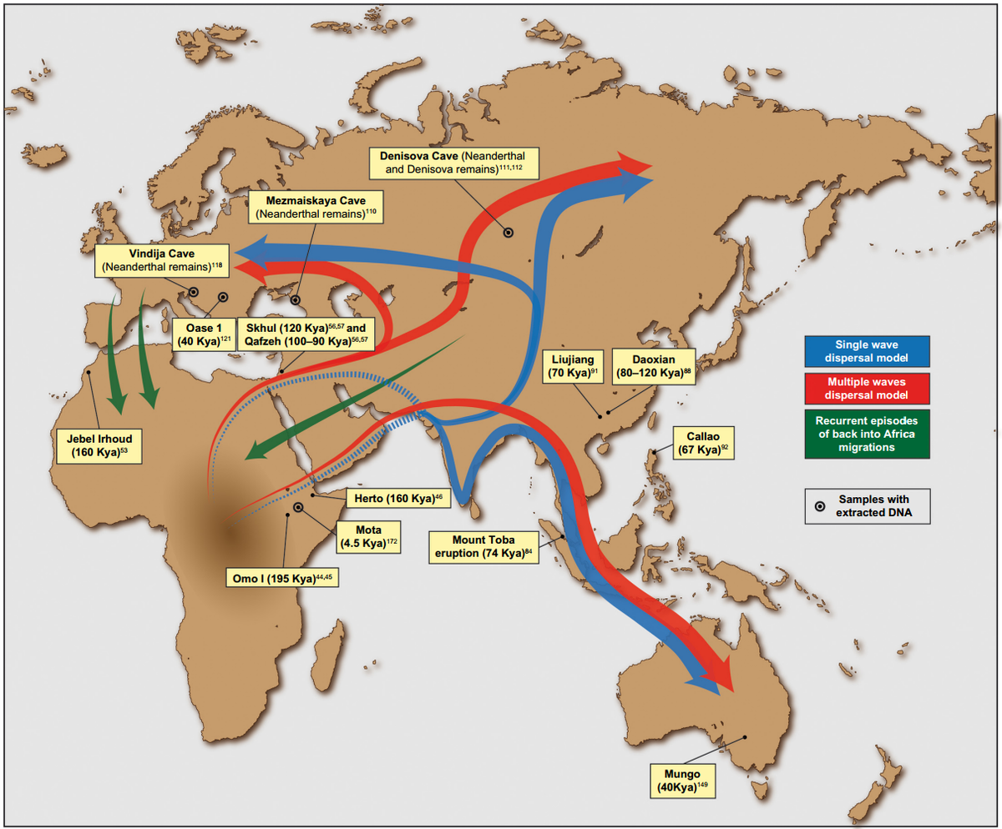

*Map showing the migratory routes of humans. [“kya” = thousand years ago]. Our haplogroup migrated from East Africa through the Arabian Peninsula to central Asia, and from there split into two groups, one migrating west to Europe, the other migrating east to China. https://en.wikipedia.org/wiki/Early_human_migrations*

~ 2,160th great-grandfather (Haplogroup G-M201) – 54,000 years ago on the Black Sea-Caspian Steppe.

About 54,000 years ago, one of Grandpa F-M89’s descendants experienced a gene mutation. He wouldn’t have known it; it’s completely painless. His name is Grandpa G-M201. (Actually, his name would be Grandpa A/F-M89/G-M201, but that’s a mouthful.) This mutation occurred in the region of the Black and Caspian Seas (today it is the area of Ossetia, Georgia, Azerbaijan, and Armenia). They stayed for about 40,000 years. At this stage of human development, Grandpa G-M201 was still a hunter gatherer, traveling all the time in small family groups. There was no such thing as a village. Grandpa G-M201’s kids became restless and hiked west towards Europe. Some of the other neighborhood kids, a smaller group, decided to move eastward, where Grandpa G-M201’s genes can be seen today as far east as China.

~ 440th great-grandfather (Haplogroup G-L497) – 11,000 years ago in Hungary.

Our side of the family meandered over to the area today known as Hungary, and lo, and behold, one of Grandpa G-M201’s grandkids mutated, and we now know him as Grandpa G-L497. Grandpa G-L497’s kids were pretty bright, they switched from a hunter-gatherer culture to a farming culture and invented goulash. (Just kidding.) But they did like the idea of staying put and growing things, instead of searching for nuts and berries all the time. The ability to farm allowed for larger families and the formation of villages. The down side of forming villages is that you need more land, and land that was conducive to farming. (Farming in the Alps was a hassle.) With each new expanding generation, more land was needed.

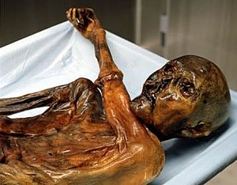

*In September of 1991, a well-preserved human mummy was found by two German tourists in the Ötzel Alps on the Austrian- Italian border. Ötzi, as he is known, was discovered at an altitude of 10,000 ft and had been preserved in the ice. Carbon dating determined he lived about 3400 to 3100 BCE. His DNA showed that he belonged to the same haplogroup as John Dollhopf. Uncle Ötzi. Google “Otzi” for info.*

Grandpa G-L497 and his kids said, “We’re outta here,” and they moved further west. A wave of migrations took place from the Black Sea region west across Europe. Along the way, hunter-gatherers were either displaced or integrated into these new farming societies. This was not a solitary event. Multiple waves flowed across Europe as new technologies evolved from the discovery and use of copper (Copper Age), bronze (Bronze Age), and then iron (Iron Age). And there was no single migration path taken across Europe. Grandpa G-L497 may have used the Danube River as a nomadic super-highway – along with many others – because he wound up in Central Europe, in the area today known as Germany.

~ 260th great-grandfather – 6,500 years ago in Central Europe.

There was no mutation at this point, but Grandpa G-L497’s kith and kin showed up in fossils at the Neolithic cemetery of *Derenburg Meerenstieg II* in north central Germany. Burial artifacts in the cemetery belong to the Linear Pottery culture (German: *Linearbandkeramik*). It is named for the type of pottery common to this era, the dawn of agrarian society – simple cups, bowls, vases, and jugs without handles. Grandpa G-L497’s kith and kin were potter’s! Coincidentally Grandpa G-L497’s descendants are one of the least common haplogroups in Europe. Seems like they had a lot of migrating neighbors.

~ 152nd great-grandfather – 3,800 years ago (800 to 500 BC) in Oberfranken.

This is known as the *Hallstatt* Period, named after the Austrian village where fossils and artifacts from this time were discovered. This was the end of the Bronze Age and beginning of the Iron Age. Humans, tired of eating the stuff they grew only on their farm, began to trade with other farmers in other villages. Trade routes were established, and there was significant migration. At this time, the culture is based on farming, but society is still organized on a tribal basis. There were hundreds of Germanic tribes. We cannot know for sure, but Dollhopfs probably belonged to a tribe known as the *Hermunduri*. Remember, though, there were no such things as surnames, so “Dollhopf” did not exist. “Grandpa G-L497” was probably too clinical, so he was probably known as “Big Red,” or the “Toothless One,” or….

~ 60th great-grandfather – 2,500 years ago (27 BC to 476 AD) Roman Empire.

Any student of Roman history will recall that the Germanic tribes of the north were barbarians. Heavens, just watch the film *Gladiator*. The area of Germany now known as Oberfranken was mostly occupied by the *Hermunduri* tribe, a relatively peaceful group. Living near the Roman frontier border region, they were known to be active traders with the Romans. Grandpa Ed Dollhopf was a salesman; maybe he inherited this from the Hermunduri.

~ 36th great Grandfather – 900 years ago (1194 AD) Bayreuth.

We don’t know for a fact *exactly* where our ancestors lived at this time, but we do know that the settlement of Bayreuth (German: *Baierrute*) was first mentioned in the records of Bishop Otto II of Bamberg. Otto, whose roots coincidentally are presumed to be in the noble family of the Mistelbachs from Mistelbach, eventually became a Catholic Bishop and was one of the leading princes of medieval Germany. He controlled many scattered societies, and was known for converting Pomerania, an area of northern Germany, to Christianity.

~ 17th great-grandfather (early to mid 1300s) Bayreuth.

Around this time in central Germany people adopted the use of surnames. Someone picked Dollhopf (at the time it was spelled *Tolhopff*). Why is a matter of debate (see *Blog 15:* *Dollhopf Name Update)*. There were several relatively large groupings of Dollhopf families in Weidenberg and Kemnath, two villages near Bayreuth, about 20 to 30 miles from Mistelbach.

16th great-grandfather (mid to late 1300s) Bayreuth.

From land records of the late 1300s we learn that a Heintz Tolhopff “owns the mill at the bridge across the Red Main River before the upper city gate of Bayreuth.” More research is needed before we can confirm that this Heintz is a direct ancestor. But we do know that Hans, below, was a miller, and likely came from Bayreuth.

15th great-grandfather (1421 AD) Mistelbach.

Hans Dollhopf (Tolhopff) is the first known Dollhopf in Mistelbach and confirmed as our direct ancestor. From the little we know about him we estimate he was born between 1400 and 1415. We know he is the first Dollhopf in Mistelbach since neither the 1398 nor the original 1421/30 property records of Mistelbach includes the name Dollhopf. At that time there was but a mere handful of farmers, about 19, in Mistelbach. The 1421/30 property records include a number of updates made until the 1440s, and one of the updates refers to Hans; he obtained a small farm that originally had been owned by a man called Angrer (no surname). This suggests that Hans Dollhopf came to Mistelbach in or about the 1430s, possibly right after the Hussites ravaged the area.

1st great-grandfather (1871) North America

John Dollhopf migrates to Pittsburgh, PA, the longest migration of our ancestors since Grandpa F-M89 migrated from the Arabian Peninsula to the Caspian Steppe.

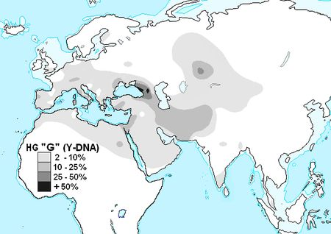

*This is the distribution of our Dollhopf Y-DNA haplogroup today. Percentages illustrate the density in population. Note the small band in East Africa to the west of Lake Victoria, the large concentration between the Black Sea and Caspian Sea (today this is the area of the country of Georgia), and the lighter concentration in southern Germany. Our genetic relatives live in these areas; this was the path of our ancestors’ migrations.*

**DNA Testing**

DNA research is just *beginning* to give us answers. I say “beginning” because the science of genetic genealogy is only now emerging on a metadata basis as millions of people now submit samples for DNA testing. Twenty years ago, DNA testing was expensive and not generally available to the public. Today, for about a hundred bucks you can purchase a DNA test. As of 2020 more than 26 million people have purchased DNA tests from one of the four major testing companies (Ancestry.com. 23andMe, Family Tree DNA, and MyHeritage.) This has provided scientists with a treasure trove of information, and, combined with fossil and site tracing, has enabled researchers to trace human evolution and migration.

Here is what DNA testing tells us:

1. How closely you are related to someone. The DNA companies generally group people into three categories: immediate family, first to third cousins, and fourth cousins or greater. How closely you are related, or the so-called “genetic distance,” is measured in centiMorgans (cMs) – the number of chromosomal bits you share with someone. The more cMs two people share, the more closely related you are. Ancestry.com tells me that as of today I have 23,399 cousins. Man, that's a lot of Christmas cards. But only 15 are third cousins or closer. Whew. The rest are fourth cousins or higher.
2. The *probable* origin of your ancestors. It can’t be exact because of the limits of testing. But it’s close. It’s not going to pinpoint Mistelbach, Germany, but it will say you have a 90% chance of being related to people from central Europe. European heritage is easier to trace than African or Asian, primarily because of the popularity of testing – many more people have been tested, so far, in Europe.
3. The risk of developing certain diseases and your health predisposition. Testing can’t yet identify all diseases, but they’re making progress; 23andMe can identify if you are a carrier of ten diseases, and they can also indicate certain wellness tendencies such as obesity, heart disease, Alzheimer’s, ability to run a four-minute mile, whether you can carry a tune (seriously), etc. 23andMe specializes in health testing.
4. Evolutionary history. This is based on the sequencing of mutations, as has been the focus of this blog.

It is important to know that DNA testing companies have different, and proprietary, testing procedures. Each company has its own special recipe of algorithms that search for similarities between you and other humans. You are tested against the humans in theirdatabase. When they test for DNA similarities, they are matching you against the other people who have sent spit to *their company*. This means that results can differ among companies.

As I mentioned above, as of this writing Ancestry.com has identified 23,399 (out of 15 million customers) cousins for me, but MyHeritage has only identified 3,456 cousins (out of 3 million), 23andMe, 1,409 cousins (out of 10 million), and Family Tree DNA, 260 cousins (out of 1 million). The size of their database seems to coincide with the relative size of their advertising budgets. More advertising means more people buying their kits. As you have probably noticed, not a TV hour slips by without seeing an ad for Ancestry.com. Their database of names dwarfs that of the other three companies. Assuming that all else is equal – such as the number of scientists employed and the quality of their methodology – the more people you test, the better the information.

The science of DNA testing is evolving, and new discoveries are always just around the corner. Each company seems to be developing new ways of grouping cousins together, most especially by matching their DNA to known family trees.

But, most people do not post a family tree with their DNA reports. While I have 23,399 cousins at Ancestry.com, most don’t provide any family tree information. For example, “John Doe” might be listed as a third cousin, but the last name Doe does not appear in my family tree. If John Doe doesn't provide the names of his great-grandparents, then I have no way of knowing how he is related. Could be my mother’s side, or my father’s. All I know is that he is related. I would say that at least 80% or more of my “cousins” on Ancestry.com have not posted a family tree. Most people, I guess, just use these tests to determine ethnicity.

**Where to Next?**

The “science” of genealogy is evolving at a breathtaking pace.

In the summer of 1978 I spent two days at the New York Public Library, meticulously poring through every German phone directory, village by village, looking for Dollhopfs. I didn’t really know Germany. We fought them in two wars. I knew that our ancestor came from a village named Mistelbach, but I didn’t know where Mistelbach was, or what it was like – rural, suburban, or urban. Was it destroyed in the war or did it survive?

When I began my “research,” my family tree had about 40 people.

I found 86 Dollhopfs in those phone directories, and wrote to each one. I heard back from all of them (some responded on behalf of others in their immediate families). It was great fun, but I was not able to connect any of them directly to us. The missing link was Mistelbach.

I wrote to the pastor in Mistelbach, hoping he would have the time to research the records and send me the information. He did not. So I hired someone to look through the church records. It was a start, but it took months. The researcher found information for about nine generations – 150 names. (But it was only a list of direct paternal ancestors, not the maternal lines.) I began drawing a family tree diagram by hand.

Remember, back then in 1977, there were no personal computers. No internet. We corresponded by *letter*. (OK, now I really sound like an old fogie.) Records such as death certificates were available only If you wrote to local government archive departments. They would send you an application, by mail. You filled it out, enclosed a check, and sent it back, by mail. Maybe six weeks later you received a response, by mail. Maybe.

By the late 80s, personal computers and family tree software enabled the collection and integration of large quantities of data, and the ability to sort that data. But that’s all. Still no internet. No fast, easy, or inexpensive way to *obtain* that data.

Then the internet. I laid my stone tablet and chisel aside and learned to push buttons. Access to census records, birth records, immigration papers! The family tree grew about 1,000 leaves. (Census data, for example, provided the names of entire families.) Companies like Ancestry.com, FamilySearch, and Newspapers.com are adding new archival information to their databases every day.

But Germany was behind the archival curve. It did not have censuses in its history; all records were mostly kept by the church, and until recently none of those records were digitized. Most still are not. The internet did, however, connect people who were researching the same trees. I connected with one Peter Bardischewski, a German amateur genealogist, who had entered most of the Mistelbach church records into his tree. He is a cousin, but we didn’t know it when we first connected. With Peter’s information our family tree grew to about 3,500 names.

As it turns out, there were also civil documents in Germany to be mined, mostly land records kept by the nobility from the 1300s to 1500s. I hired yet another professional and went deeper and further back in time, adding five generations to our tree. We now have about 4,000 leaves on that tree.

Now we have DNA testing. I have more than 25,000 newly discovered cousins as I described above, but most of them are not in the family tree *because I don’t know how they are related!* Unless they post a family tree online, I have no way of knowing how “Jane and John Doe” are connected to us.

But more and more people *are* posting trees online, and interest in genealogy is viral, spreading in waves and pockets. I recently joined the *Gesellschaft für Familienforschung in Franken* (the Society for Family Research in Franconia) and am now connected with hundreds who are researching families in the Bayreuth area.

Peter Bardischewski connected with this group, and his tree now includes 42,000 individuals. I am beginning the process of integrating those names into our tree, but they all need to be verified. When I get around to it.

From 40 to 40,000 known relatives in less than a generation, and here’s the kicker: I’ve only climbed the Dollhopf tree. I have 12 other great-grandparents who came from other villages in Europe, branches of the family tree begging to be climbed!

We are truly on the threshold of an enormous discovery curve. As millions more people test their DNA, and as they begin to upload their family information, it dramatically increases the likelihood of connecting to long ignored or buried family trees, long forgotten photographs, and bits and pieces of information that contribute to the creation of this giant jigsaw puzzle we call family.

What does this matter, you might ask? Everyone has a history.

Well, yes they do. But they don’t have *our* history. They don’t have the same stories, the same archetypes, the same symbols. And they don’t have the same networks of people who care about each other and enrich each other’s lives.

As our tree grows, our world grows. I’ve found new relatives, new friends – in Germany, Austria, Australia, and of course many in the US. I’ve discovered people with interests and passions that match my own, as well as those who offer revealing counterpoints.

I have a deeper and more critical understanding of history, and the political and economic forces that shaped society – especially a society – and a family – torn apart by world wars. The Dollhopfs had first cousins on opposite sides of the battle in the trenches of WWI.

On my mother’s side I’ve learned of the farm my 10th great-grandfather owned on the island of Manhattan, when it was still known as New Amsterdam, and of the regiments my grandfathers joined in the Revolutionary War, the War of 1812, and the Civil War, and the battles they fought.

I’ve been exposed to different cultures – not merely German, but those within Germany – Franconian and Hessen (very different). I’ve hiked in Franconian forests, shopped in Franconian Christmas markets, and learned to cook Franconian sauerbraten. And drink Franconian *schnapps*. I’m learning a new language. Sort of.

Genealogy is not aboutthe past; it’s aboutthe present.

Mark Dollhopf

New Haven, CT

June 7, 2020 (*In anno corona virum.*)

1. This information comes from DNA testing at 23andMe and FamilyTree DNA.
2. With the exception of our great-grandfather, Johann, who probably did not have a mutation, but we know he came to America because we have written evidence. And because we’re here, duh.
3. 21,000 years ago, the Arabian Peninsula, the location today of Saudi Arabia, was lush grassland, not a desert.
4. As far as I know these alphabet labels do not stand for anything in particular.
5. Genes mutate by accident when cells divide, or sometimes there is an external cause, say ultraviolet light from the sun – the reason why some humans developed white skin.